Task 1: Create a bash script to check if a directory is available or not

Outcome
A Bash script was created to check whether a specified directory exists on a Linux system. The script displays an appropriate message depending on whether the directory exists.

Objective

The objective of this task was to create and execute a Bash script using conditional statements to determine whether a directory is available at a specified path.

Prerequisites
- A Linux system or AWS EC2 Linux instance.
- Git Bash or a Linux terminal.
- Basic knowledge of Bash scripting.
- Permission to access the directory being checked.

Step-by-Step Implementation

Step 1: Connect to the Linux Instance
If using AWS EC2, opened Git Bash and connected to the instance:
ssh -i "your-key.pem" ec2-user@YOUR_EC2_PUBLIC_IP
Replace the key filename and public IP address with the actual EC2 details.

Step 2: Create a Bash Script
Created a script named check_directory.sh:
vim check_directory.sh

Step 3: Write the Bash Script
Entered the following code into the file:
#!/bin/bash

echo "Enter directory path:"
read -r dir

if [ -d "$dir" ]; then
echo "Directory exists."
else
echo "Directory does not exist."
fi
Saved the file by pressing Ctrl+O, then Enter, and exited using Ctrl+X.
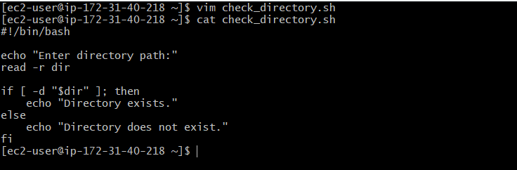

Step 4: Provide Execute Permission
Made the script executable:
chmod 755 check_directory.sh

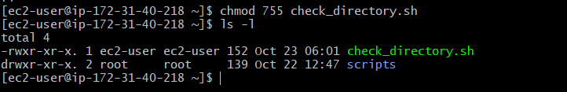

Step 5: Execute the Script
Ran the script:
./check_directory.sh
The script prompts the user to enter a directory path.
Example 1: Directory exists
Input:
Enter directory path:
/home/ec2-user
Expected output:
Directory exists.

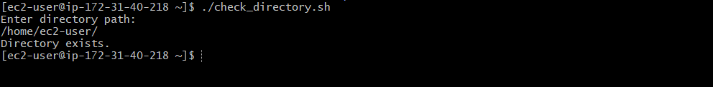

Example 2: Directory does not exist
Input:
Enter directory path:
/home/ec2-user/unknown
Expected output:
Directory does not exist.
The output depends on whether the specified directory actually exists.
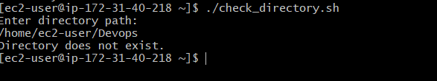

Validation Steps
Validation | Command or Method | Expected Result
Script creation | ls -l check_directory.sh | Script file is present
Execute permission | chmod +x check_directory.sh | Script can be executed
Run the script | ./check_directory.sh | Directory path prompt appears
Existing directory | Enter a valid directory path | Directory exists.
Missing directory | Enter a nonexistent directory path | Directory does not exist.

Explanation
The script uses the Bash conditional statement if...else to check the specified directory.
#!/bin/bash identifies Bash as the script interpreter.
read -r dir accepts a directory path from the user.
[ -d "$dir" ] checks whether the path exists and is a directory.
then executes the first block when the directory exists.
else executes the alternative block when the condition is false.
fi marks the end of the conditional statement.
The quotation marks around "$dir" ensure that directory paths containing spaces are handled correctly.

Real-Time Use Case
Directory existence checks are useful in DevOps automation scripts before creating files, copying application content, or starting deployment procedures. For example, a deployment script can check whether an application directory exists before copying new files into it.

Common Errors and Troubleshooting
Error or Issue | Possible Cause | Solution
Permission denied | Script does not have execute permission | Run chmod +x check_directory.sh
Command not found | Script is run without the correct path | Run ./check_directory.sh
Incorrect result | Entered path is incorrect | Verify the directory path
Script syntax error | Missing quotation marks or fi | Check the script syntax
File exists but reports missing directory | The path refers to a regular file rather than a directory | Verify that the path is a directory

Conclusion
A Bash script was created to check whether a specified directory exists on a Linux system. The script uses the -d conditional test and an if...else statement to display the appropriate result. This task demonstrates a basic Bash scripting technique useful for Linux administration and DevOps automation.
Task 2: Create a bash script to create multiple files

Outcome
A Bash script was created to create multiple files automatically in a specified directory. The script accepts the directory path and filenames as command-line arguments and creates the requested files.

Objective
The objective of this task was to automate file creation using Bash scripting and command-line arguments, reducing the need to create files individually.

Prerequisites
- A Linux system or AWS EC2 Linux instance.
- Git Bash or a Linux terminal.
- Basic knowledge of Bash scripting.
- Write permission for the target directory.

Step-by-Step Implementation

Step 1: Create the Bash Script
Created a file named create_files.sh:
vim create_files.sh

Step 2: Write the Bash Script
Entered the following code:
#!/bin/bash

if [ "$#" -lt 2 ]; then
echo "Usage: $0 <directory_path> <file1> [file2 ...]"
exit 1
fi

dir="$1"
shift

if [ ! -d "$dir" ]; then
echo "Error: Directory does not exist: $dir"
exit 2
fi

for file in "$@"; do
if [ -e "$dir/$file" ]; then
echo "Skipped: $dir/$file already exists."
else
if touch "$dir/$file"; then
echo "Created: $dir/$file"
else
echo "Error: Could not create $dir/$file"
fi
fi
done
Saved the file using Ctrl+O, pressed Enter, and exited using Ctrl+X.
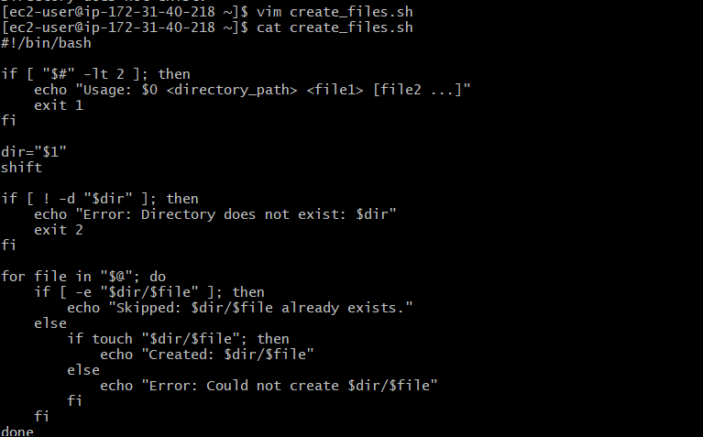

Step 3: Provide Execute Permission
Made the script executable:
chmod 755 create_files.sh

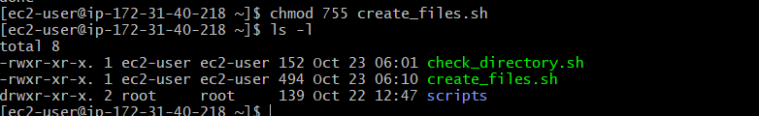

Step 4: Create a Directory for Testing
Created a test directory:
mkdir -p /home/ec2-user/testfiles

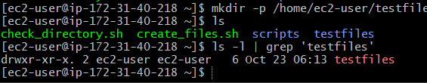

Step 5: Execute the Script
Ran the script with a directory path and multiple filenames as arguments:

Expected output:
Created: /home/ec2-user/testfiles/file1.txt
Created: /home/ec2-user/testfiles/file2.txt
Created: /home/ec2-user/testfiles/file3.txt
The output assumes that these files did not already exist.

Step 6: Verify the Created Files
Listed the contents of the target directory:
ls -l /home/ec2-user/testfiles
Expected result: file1.txt, file2.txt, and file3.txt appear in the directory listing.
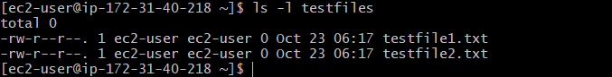

Step 7: Test Existing Files
Ran the same command again:
./create_files.sh /home/ec2-user/testfiles file1.txt file2.txt file3.txt
Expected output:
Skipped: /home/ec2-user/testfiles/file1.txt already exists.
Skipped: /home/ec2-user/testfiles/file2.txt already exists.
Skipped: /home/ec2-user/testfiles/file3.txt already exists.
The script skips existing paths instead of overwriting their contents.

Validation Steps
Validation | Command or Method | Expected Result
Script creation | ls -l create_files.sh | Script file exists
Execute permission | chmod +x create_files.sh | Script can be executed
Create multiple files | Run the script with several filenames | Files are created
Verify files | ls -l /home/ec2-user/testfiles | All requested files are listed
Existing file handling | Run the script again | Existing files are skipped
Missing directory | Provide a nonexistent directory | Error message is displayed

Explanation
The script uses command-line arguments to specify the destination directory and the filenames to create.
$# checks the number of supplied arguments.
$1 contains the directory path.
shift removes the directory argument so the remaining arguments contain only filenames.
"$@" processes each filename separately, including filenames containing spaces when passed correctly.
-d checks whether the destination exists and is a directory.
-e checks whether a path already exists.
touch creates an empty file when it does not already exist.
The for loop processes all supplied filenames.

Real-Time Use Case
Creating multiple files with a Bash script is useful in DevOps automation when preparing application directories, generating configuration files, creating log files, or setting up test environments.
For example, a deployment script can create several required files before copying application content or running automated tests.

Common Errors and Troubleshooting
Error or Issue | Possible Cause | Solution
Permission denied | Insufficient write permissions | Use a directory where your user has write permission
Directory does not exist | Incorrect target path | Verify the directory path
Script cannot run | Execute permission is missing | Run chmod +x create_files.sh
Usage message appears | Too few arguments supplied | Provide the directory path and at least one filename
File already exists | The requested file is present | The script skips it to avoid overwriting
File creation fails | Invalid path or filesystem permissions | Check the filename and target directory permissions

Conclusion
A Bash script was created to automate the creation of multiple files in a specified directory. The script accepts command-line arguments, checks that the destination directory exists, skips existing files, and reports the results. This task demonstrates how Bash scripting can simplify repetitive file-management operations in Linux and DevOps environments.
Task 3: Create a bash script to take a backup of a directory

Outcome
A Bash script was created to take a backup of a specified directory. The script accepts the source directory as a command-line argument and creates a compressed .tar.gz backup file with a timestamp.

Objective
The objective of this task was to automate directory backup using Bash scripting. The script checks whether the source directory exists, creates a compressed archive, and stores the backup in a specified backup location.

Prerequisites
- A Linux system or AWS EC2 Linux instance.
- Git Bash or a Linux terminal.
- Basic knowledge of Bash scripting.
- Read permission for the source directory.
- Write permission for the backup destination.
- Sufficient disk space to store the backup.

Step-by-Step Implementation

Step 1: Create the Bash Script
Created a script named backup_directory.sh:
vim backup_directory.sh

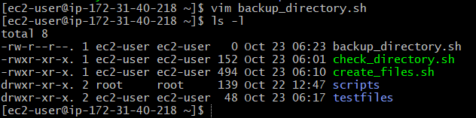

Step 2: Write the Bash Script
Entered the following code:
#!/bin/bash

if [ "$#" -ne 2 ]; then
echo "Usage: $0 <source_directory> <backup_directory>"
exit 1
fi

source_dir="${1%/}"
backup_dir="$2"

if [ ! -d "$source_dir" ]; then
echo "Error: Source directory does not exist: $source_dir"
exit 2
fi

mkdir -p "$backup_dir" || {
echo "Error: Could not create backup directory: $backup_dir"
exit 3
}

timestamp=$(date +"%Y%m%d_%H%M%S")
archive_name="$(basename "$source_dir")_backup_${timestamp}.tar.gz"
backup_file="$backup_dir/$archive_name"

if tar -czf "$backup_file" -C "$(dirname "$source_dir")" "$(basename "$source_dir")"; then
echo "Backup completed successfully."
echo "Backup file: $backup_file"
else
echo "Error: Backup failed."
rm -f "$backup_file"
exit 4
fi
Saved the file using Ctrl+O, pressed Enter, and exited using Ctrl+X.
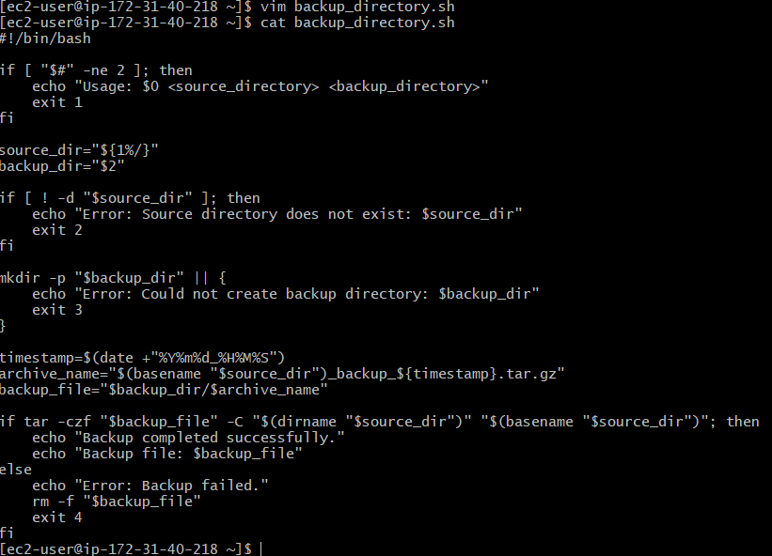

Step 3: Provide Execute Permission
Made the script executable:
chmod 755 backup_directory.sh

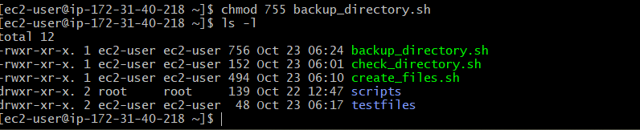

Step 4: Create a Sample Directory
Created a directory containing sample files for testing:
mkdir -p /home/ec2-user/project
echo "Sample project file" > /home/ec2-user/project/file1.txt
echo "Backup testing" > /home/ec2-user/project/file2.txt

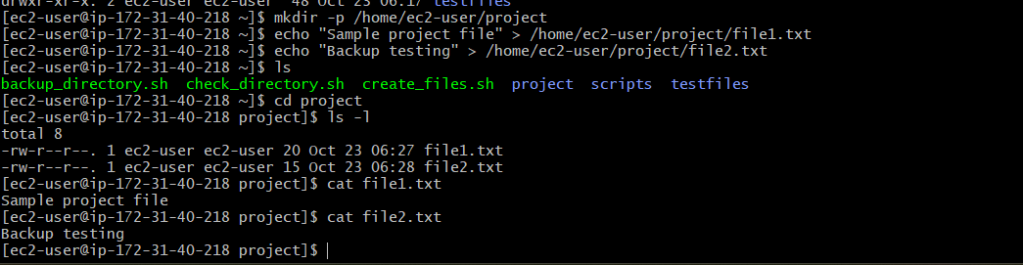

Step 5: Create a Backup
Executed the script by providing the source directory and backup destination as arguments:
./backup_directory.sh /home/ec2-user/project /home/ec2-user/backups
Example output:
Backup completed successfully.
Backup file: /home/ec2-user/backups/project_backup_20261022_120000.tar.gz
The timestamp in the filename will depend on the actual date and time when the script runs.

Step 6: Verify the Backup File
Listed the contents of the backup directory:
ls -lh /home/ec2-user/backups
Expected result: A compressed backup file with the .tar.gz extension appears in the directory listing.
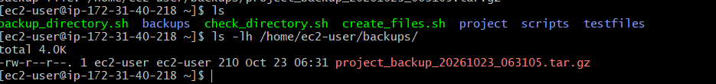

Step 7: Verify the Archive Contents
Used the following command to inspect the files stored in the archive:
tar -tzf /home/ec2-user/backups/project_backup_*.tar.gz
Expected result: The archive lists the project directory and its files, including file1.txt and file2.txt.

Validation Steps
Validation | Command or Method | Expected Result
Script creation | ls -l backup_directory.sh | Script file exists
Execute permission | chmod +x backup_directory.sh | Script can be executed
Source directory check | Run script with a valid source path | Backup process starts
Backup creation | Run the backup script | Compressed archive is created
Verify backup file | ls -lh /home/ec2-user/backups | Backup file is listed
Verify archive contents | tar -tzf /home/ec2-user/backups/project_backup_*.tar.gz | Source files appear in the archive
Invalid source path | Run script with a nonexistent source directory | Error message is displayed

Explanation
The script uses Bash commands and conditional statements to create a compressed backup of a directory.
#!/bin/bash identifies Bash as the script interpreter.
$# checks the number of command-line arguments.
$1 specifies the source directory.
$2 specifies the backup destination.
-d checks whether the source directory exists.
mkdir -p creates the backup directory if it does not exist.
date generates a timestamp to make each backup filename unique under normal usage.
tar -czf creates a compressed archive using gzip.
-C changes the directory used as the archive's starting point, so the archive contains the source directory by name rather than its full absolute path.
tar -tzf lists the archive contents without extracting them.
exit returns a status code to indicate success or failure.

Real-Time Use Case
Directory backups are important in DevOps and Linux administration for protecting application files, configuration files, website content, and project data.
For example, an administrator can run this script before updating a website or deploying a new application version. If a problem occurs, the backup archive can be used to restore the previous files.
For important production data, backups should also be copied to separate storage, such as Amazon S3, and periodically tested through restoration.

Common Errors and Troubleshooting
Error or Issue | Possible Cause | Solution
Source directory does not exist | Incorrect source path | Verify the directory path
Permission denied | Insufficient read or write permissions | Check permissions on the source and backup directories
Backup creation fails | Insufficient disk space or unreadable files | Check available storage and file permissions
Script cannot run | Execute permission is missing | Run chmod +x backup_directory.sh
Backup file is missing | Incorrect backup destination | Check the second command-line argument
Archive cannot be listed | Backup file is incomplete or invalid | Rerun the backup and check the command output

Conclusion
A Bash script was created to back up a specified directory into a timestamped, compressed .tar.gz archive. The script validates the source directory, creates the backup destination when necessary, and reports whether the backup succeeds. This task demonstrates how Bash scripting can automate routine data-protection operations in Linux and DevOps environments.
Task 4:Create a bash script to install Nginx on an EC2 server.

Outcome
A Bash script was created to automate the installation and configuration of the Nginx web server on an AWS EC2 Linux instance. The script detects the package manager, installs Nginx, starts the service, and enables it to start automatically when the instance boots.

Objective
The objective of this task was to automate Nginx installation on an EC2 server using Bash scripting, reducing the need to execute installation and service-management commands manually.

Prerequisites
- An AWS account.
- A running EC2 Linux instance.
- Git Bash installed on the local computer.
- A valid EC2 private key file (.pem).
- SSH access to the EC2 instance.
- An internet connection from the EC2 instance.
- A user account with sudo privileges.
- An EC2 security group configured to allow the required HTTP traffic.

Step-by-Step Implementation

Step 1: Connect to the EC2 Instance Using Git Bash
Opened Git Bash and connected to the EC2 instance:
ssh -i "your-key.pem" ec2-user@YOUR_EC2_PUBLIC_IP
Replaced the key filename and public IP address with the actual EC2 details.

Step 2: Create the Bash Script
Created a script named install_nginx.sh:
vim install_nginx.sh
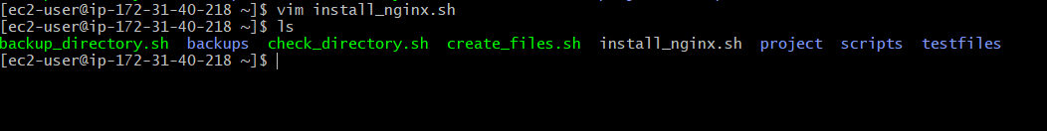

Step 3: Write the Bash Script
Entered the following code:
#!/bin/bash

set -e

echo "Starting Nginx installation..."

if ! command -v sudo >/dev/null 2>&1; then
echo "Error: sudo is required to install Nginx."
exit 1
fi

if command -v dnf >/dev/null 2>&1; then
sudo dnf install -y nginx
elif command -v apt-get >/dev/null 2>&1; then
sudo apt-get update
sudo apt-get install -y nginx
else
echo "Error: Unsupported package manager."
echo "This script supports DNF and APT-based Linux systems."
exit 1
fi

sudo systemctl enable --now nginx

echo "Checking Nginx service status..."
sudo systemctl status nginx --no-pager

echo "Nginx installation and service startup completed."
Saved the file by pressing Ctrl+O, then Enter, and exited using Ctrl+X.
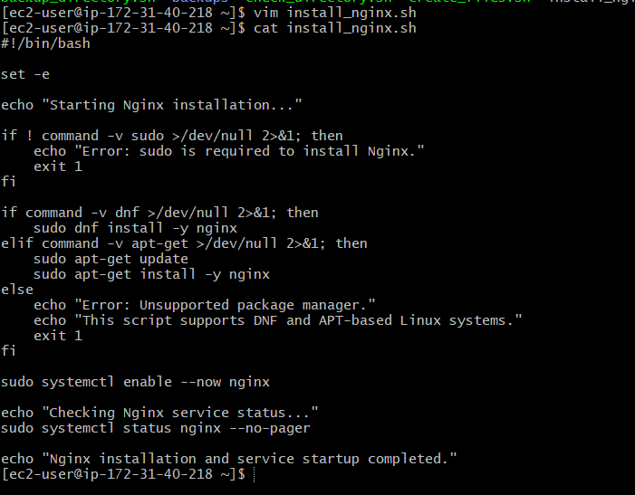

Step 4: Provide Execute Permission
Made the script executable:
chmod 755 install_nginx.sh

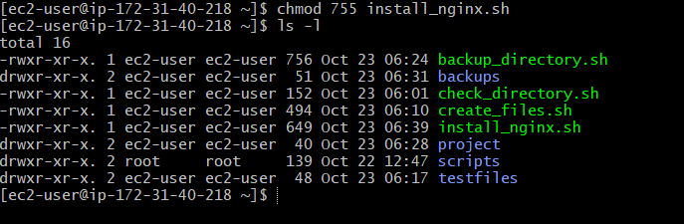

Step 5: Execute the Script
Ran the installation script:
./install_nginx.sh
Entered the sudo password if prompted. On a typical EC2 instance using the default administrative user, sudo may not require a password.
The script detects the available package manager:
dnf is used on Amazon Linux 2023.
apt-get is used on Ubuntu and other supported Debian-based systems.
The script then installs Nginx, enables the service, and starts it.
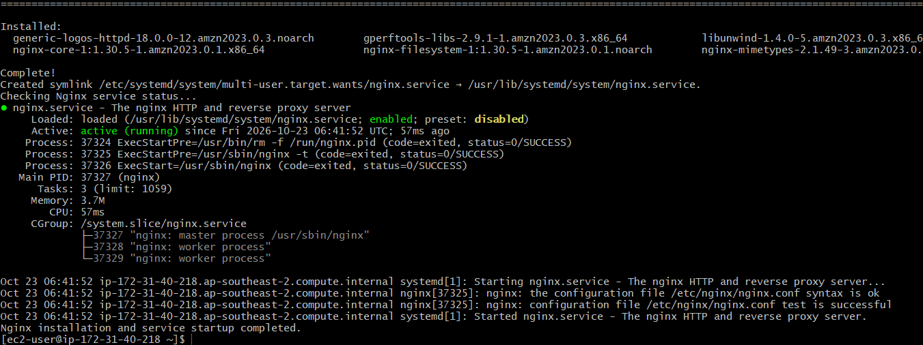

Step 6: Verify the Nginx Installation
Checked the installed version:
nginx -v
Expected result: The installed Nginx version is displayed.
Checked the service status:
sudo systemctl status nginx --no-pager
Expected result: The service shows active (running).
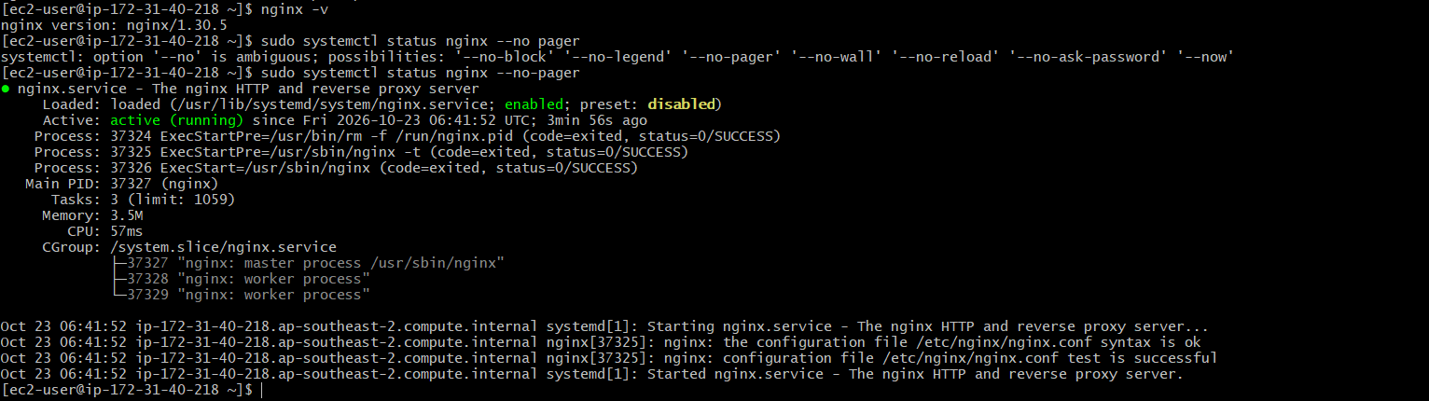

Step 7: Verify the Listening Port
Checked whether Nginx is listening on the default HTTP port 80:
sudo ss -lntp | grep ':80'
Tested the local HTTP response:
curl -I http://localhost/
Expected result: An HTTP response is returned from Nginx.
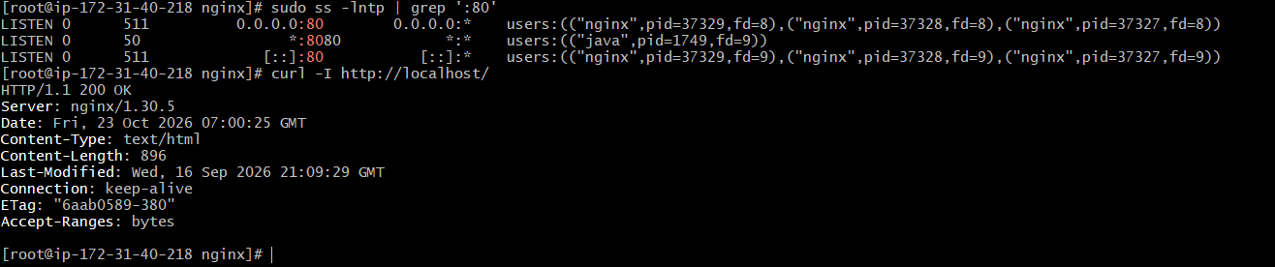

Step 8: Access Nginx Through a Web Browser
In the AWS EC2 console, verified that the instance's security group permits inbound TCP port 80 from the intended client IP address.

Opened a browser and entered:
http://YOUR_EC2_PUBLIC_IP/
Replaced YOUR_EC2_PUBLIC_IP with the actual public IPv4 address of the EC2 instance.
Expected result: The Nginx welcome page or configured website is displayed.
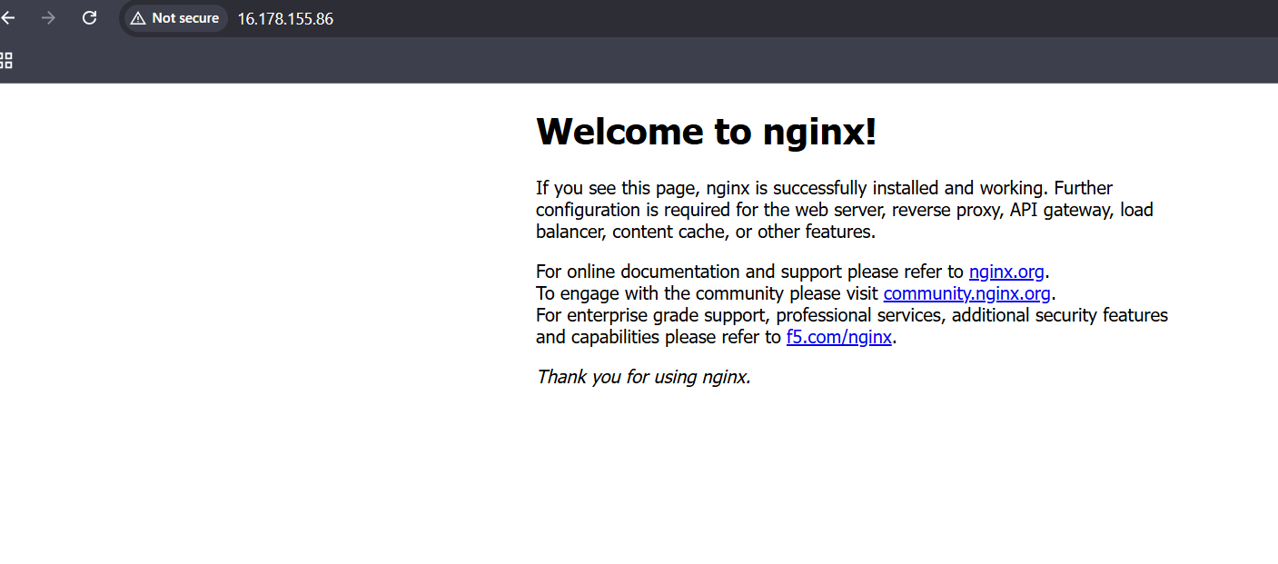

Validation Steps
Validation | Command or Method | Expected Result
Script creation | ls -l install_nginx.sh | Script file exists
Execute permission | chmod +x install_nginx.sh | Script can be executed
Script execution | ./install_nginx.sh | Installation commands execute
Nginx version | nginx -v | Version information displayed
Service status | sudo systemctl status nginx --no-pager | active (running)
Port verification | sudo ss -lntp | grep ':80' | Nginx listening on port 80
Local HTTP test | curl -I http://localhost/ | HTTP response received
Browser test | Open the EC2 public IP | Nginx page displayed if network access is configured

Explanation
Bash scripting allows administrators to automate repetitive Linux administration tasks.
#!/bin/bash specifies the Bash interpreter.
set -e stops the script when a command fails.
command -v dnf checks whether the DNF package manager is available.
command -v apt-get checks whether the APT package manager is available.
dnf install -y nginx installs Nginx on supported DNF-based systems.
apt-get update refreshes package information on APT-based systems.
apt-get install -y nginx installs Nginx on supported APT-based systems.
systemctl enable --now nginx enables Nginx at boot and starts it immediately.
nginx -v displays the installed version.
curl -I checks the HTTP response headers.

Real-Time Use Case
Automated Nginx installation is useful when preparing cloud servers for website hosting, reverse proxy configuration, or deployment pipelines.
In a DevOps workflow, the script can be incorporated into instance initialization or configuration-management processes to reduce manual work and provide a consistent installation procedure.

Common Errors and Troubleshooting
Error or Issue | Possible Cause | Solution
Permission denied | Script is not executable | Run chmod +x install_nginx.sh
Package manager not supported | The operating system uses a different package manager | Adapt the script to the installed Linux distribution
Package installation fails | Network, repository, or package-manager issue | Check internet connectivity and package repositories
Nginx fails to start | Configuration error or port conflict | Run sudo nginx -t and inspect service logs
Port 80 is unavailable | Another service is using port 80 | Check sudo ss -lntp and resolve the port conflict
Browser cannot access Nginx | Security group or firewall blocks traffic | Check inbound TCP port 80 and firewall rules
Script stops unexpectedly | A command failed because set -e is enabled | Inspect the preceding error message and correct the cause

Conclusion
A Bash script was created to automate Nginx installation on an AWS EC2 Linux instance. The script detects the package manager, installs Nginx, starts the service, and enables it at boot. The installation can be verified using the Nginx version command, systemd service status, listening-port checks, and an HTTP request. Successful browser access confirms that Nginx is reachable when the network configuration is correct.
Task 5: Create a bash script to install Apache Tomcat on an EC2 server.

Outcome
Successfully create a Bash script to install Apache Tomcat on an AWS EC2 Linux server, configure the Tomcat service to start automatically, and verify its status.

Objective
To automate the installation and startup of Apache Tomcat on an EC2 instance using a Bash script, reducing manual effort and ensuring consistent deployment.

Prerequisites
- An AWS account with an EC2 Linux instance.
- SSH access to the EC2 instance.
- A Linux-based operating system, such as Amazon Linux 2023.
- A user account with sudo privileges.
- An active internet connection to download the required packages.

Step-by-Step Implementation

Step 1: Connect to the EC2 Instance
Open Git Bash on your local computer and connect to your EC2 instance using your SSH key.
ssh -i "your-key.pem" ec2-user@YOUR_EC2_PUBLIC_IP
Replace your-key.pem with your private key filename and YOUR_EC2_PUBLIC_IP with your instance's public IP address.

Step 2: Create the Bash Script
Create a script named install_tomcat.sh.
vim install_tomcat.sh
Add the following code:
#!/bin/bash

set -e

echo "Starting Apache Tomcat installation..."

# Install Tomcat using the available package manager
if command -v dnf >/dev/null 2>&1; then
sudo dnf install -y tomcat
elif command -v yum >/dev/null 2>&1; then
sudo yum install -y tomcat
elif command -v apt-get >/dev/null 2>&1; then
sudo apt-get update
sudo apt-get install -y tomcat9
else
echo "Error: Unsupported package manager."
exit 1
fi

# Start and enable the Tomcat service
if systemctl list-unit-files --type=service --no-legend \
| grep -q '^tomcat9\.service'; then
TOMCAT_SERVICE="tomcat9"
elif systemctl list-unit-files --type=service --no-legend \
| grep -q '^tomcat\.service'; then
TOMCAT_SERVICE="tomcat"
else
echo "Error: Could not find the installed Tomcat service."
echo "Check the package and service name for this Linux distribution."
exit 1
fi

sudo systemctl enable --now "$TOMCAT_SERVICE"

echo "Checking Tomcat service status..."
sudo systemctl status "$TOMCAT_SERVICE" --no-pager

echo "Tomcat installation and startup completed."
Save the file and exit the editor.
Note: Package and service names vary by Linux distribution. On Amazon Linux 2023, check the available Tomcat package and service names if the script cannot find them.
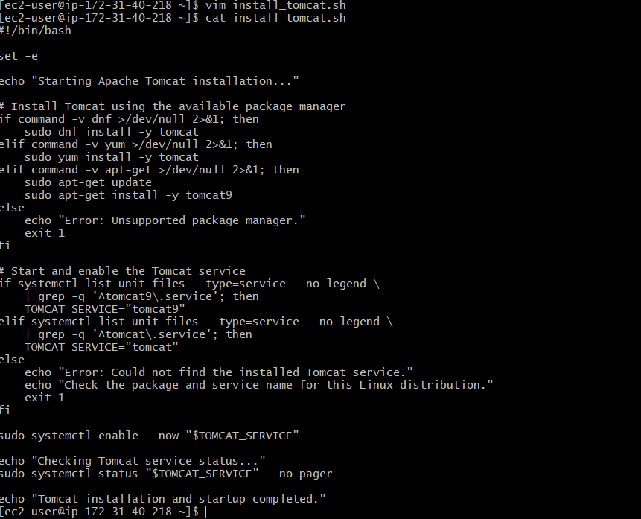

Step 3: Give Execute Permission
chmod 755 install_tomcat.sh
This allows the script to be executed directly.
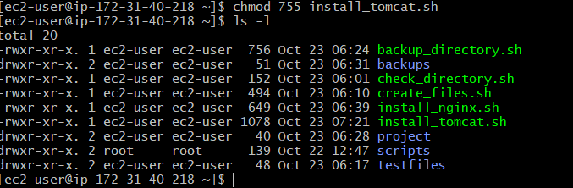

Step 4: Execute the Script
./install_tomcat.sh
The script installs Tomcat using the available package manager, enables the service at boot, and attempts to start it immediately.
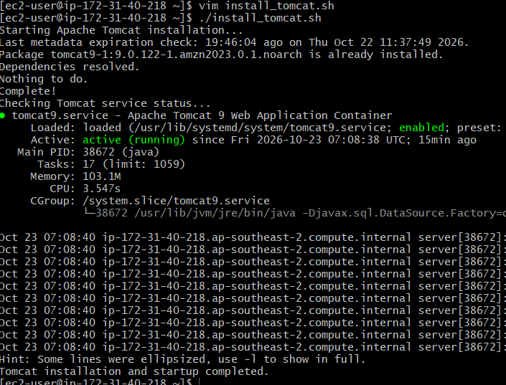

Step 5: Verify the Installation
Check the service status:
sudo systemctl status tomcat --no-pager
If your system uses the tomcat9 service, run:
sudo systemctl status tomcat9 --no-pager
Check whether Tomcat is listening on its configured port:
sudo ss -ltnp
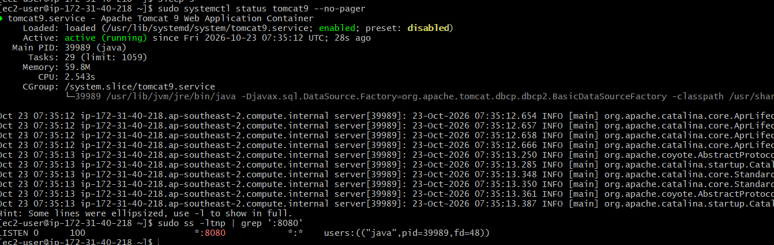

Step 6: Test Tomcat
From the EC2 instance, test the configured port. For example, if Tomcat is configured for port 8080:
curl -I http://localhost/
If Tomcat is configured for port 8080, use:
curl -I http://localhost:8080/

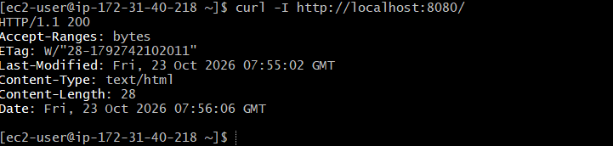
To access Tomcat from a browser, use:
http://YOUR_EC2_PUBLIC_IP:8080/
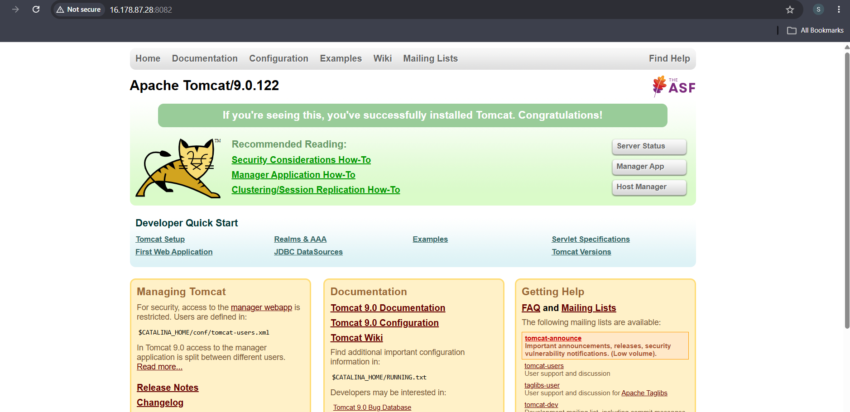

Validation Steps
No. | Validation | Expected Result
1 | Run ls -l install_tomcat.sh | Script file exists and has execute permission
2 | Execute ./install_tomcat.sh | Installation commands complete without errors
3 | Check systemctl status | Tomcat service is active
4 | Run sudo ss -ltnp | Tomcat is listening on its configured port
5 | Run curl -I http://localhost:PORT/ | An HTTP response is received if the server is responding

Explanation
The Bash script automates the main steps required to install and start Apache Tomcat:
#!/bin/bash specifies the Bash interpreter.
set -e stops the script when a command fails.
command -v identifies the package manager available on the server.
dnf, yum, or apt-get installs the Tomcat package.
systemctl enable --now enables the service at boot and starts it immediately.
systemctl status displays whether the service is running.
ss -ltnp helps verify which TCP ports are listening.
The installation package determines the service name and file locations. Therefore, these should be checked on the target EC2 operating system.

Real-Time Use Case
In a DevOps environment, administrators often need to install application servers on newly provisioned EC2 instances. A Bash installation script automates this repetitive task and helps standardize server setup across development, testing, and staging environments.

Common Errors and Troubleshooting
Error | Possible Cause | Solution
Permission denied | Script does not have execute permission | Run chmod +x install_tomcat.sh
sudo: command not found | The environment lacks sudo | Use an authorized administrative account or install/configure sudo
Package not found | Package name is unavailable for the operating system | Check the OS version and available Tomcat packages
Unit not found | The service name differs from the script's expected name | Run `systemctl list-unit-files | grep -i tomcat`
Service fails to start | Invalid configuration, missing dependencies, or port conflict | Inspect sudo journalctl -u tomcat -xe or the matching Tomcat service name
Browser cannot connect | Incorrect port, security group rule, or Tomcat not listening | Check the Tomcat connector configuration, ss -ltnp, and the EC2 security group

Conclusion
A Bash script was created to automate Apache Tomcat installation and service startup on an EC2 Linux server. The script selects a package manager, installs Tomcat, enables and starts the service, and verifies its status. The final port and service name should be confirmed for the specific EC2 operating system.
Task 6: Create a bash script to check if the Nginx service is running, if not running then script should start the service.

Outcome
A Bash script is created to check the status of the Nginx service. If Nginx is not running, the script automatically attempts to start it and verifies the service status.

Objective
To automate Nginx service monitoring and recovery using a Bash script on an AWS EC2 Linux server.

Prerequisites
- An AWS EC2 instance running Linux, such as Amazon Linux 2023.
- SSH access to the EC2 instance.
- Nginx installed on the server.
- A user account with sudo privileges.
- Basic knowledge of Linux commands and Bash scripting.

Step-by-Step Implementation

Step 1: Connect to the EC2 Instance
Connect to your EC2 instance using Git Bash.
ssh -i "your-key.pem" ec2-user@YOUR_EC2_PUBLIC_IP
Replace the key filename and public IP address with your EC2 details.

Step 2: Create the Bash Script
Create a file named check_nginx.sh.
vim check_nginx.sh
Add the following code:
#!/bin/bash

SERVICE="nginx"

echo "Checking Nginx service status..."

if systemctl is-active --quiet "$SERVICE"; then
echo "Nginx is already running."
else
echo "Nginx is not running. Attempting to start it..."

if sudo systemctl start "$SERVICE"; then
echo "Nginx start command executed."
else
echo "Error: Failed to start Nginx."
echo "Check the service logs for details."
exit 1
fi
fi

# Verify the final service status
if systemctl is-active --quiet "$SERVICE"; then
echo "Success: Nginx is running."
exit 0
else
echo "Error: Nginx is still not running."
sudo systemctl status "$SERVICE" --no-pager
exit 1
fi
Save the file and exit the editor.
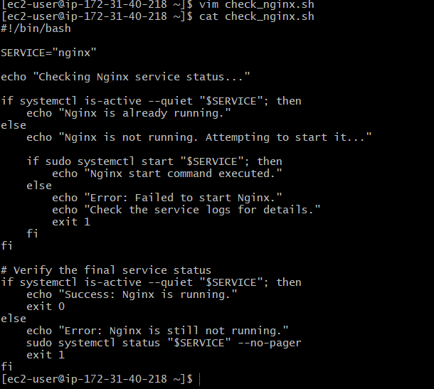

Step 3: Give Execute Permission
Run the following command to make the script executable:
chmod 755 check_nginx.sh
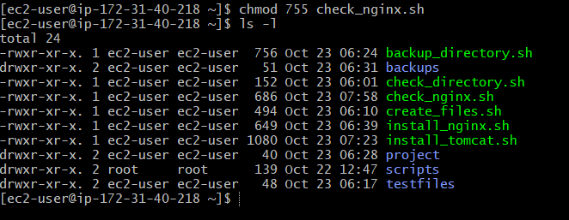

Step 4: Execute the Script
Run the script:
./check_nginx.sh
If Nginx is already running, the script reports that it is active. If it is stopped, the script attempts to start it and then checks its status again.
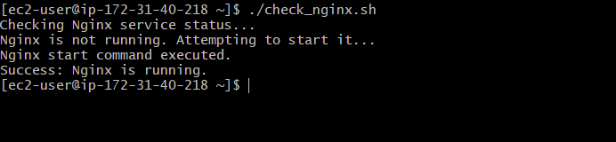

Step 5: Verify the Nginx Service
Check the service manually:
sudo systemctl status nginx --no-pager
You can also check whether Nginx is listening on the configured port:
sudo ss -ltnp | grep nginx

sudo ss -ltnp | grep ':80'

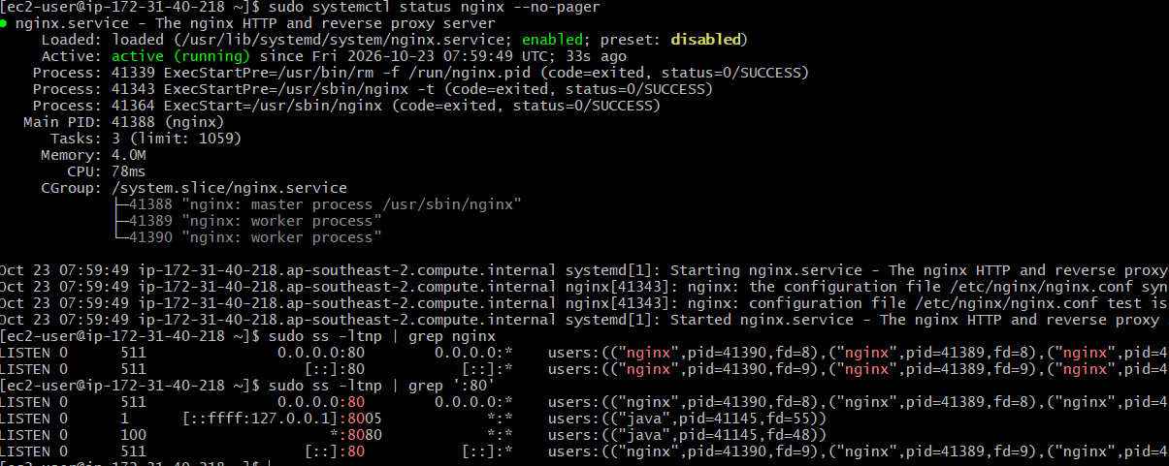

Validation Steps
No. | Test | Expected Result
1 | Run chmod +x check_nginx.sh | Execute permission is granted
2 | Run ./check_nginx.sh while Nginx is running | Script reports that Nginx is already running
3 | Stop Nginx with sudo systemctl stop nginx and run the script | Script attempts to start Nginx
4 | Run sudo systemctl status nginx --no-pager | Service status shows active (running) if startup succeeds
5 | Run sudo ss -ltnp | Nginx listening port is displayed if configured and active

Explanation
#!/bin/bash specifies that the script should run using Bash.
SERVICE="nginx" stores the service name in a variable.
systemctl is-active --quiet checks whether Nginx is running without printing status output.
if and else determine whether the script should start Nginx.
sudo systemctl start nginx attempts to start the service when it is inactive.
The final status check confirms whether the service is running after the attempt.
exit 0 indicates success, while exit 1 indicates failure.
Note: This script starts Nginx when it is stopped, but it does not automatically enable Nginx to start after a server reboot. To enable startup at boot, run:
sudo systemctl enable nginx

Real-Time Use Case
In a DevOps environment, web servers must remain available to serve application traffic. This script can be used as part of a basic monitoring or recovery workflow to detect a stopped Nginx service and attempt to restore it without requiring manual intervention.

Common Errors and Troubleshooting
Error | Possible Cause | Solution
Unit nginx.service could not be found | Nginx is not installed or the service name differs | Install Nginx and verify the service name
Permission denied | Insufficient permissions | Run the script with an authorized account and ensure sudo access
Nginx fails to start | Invalid configuration or port conflict | Run sudo nginx -t to test the configuration
Service remains inactive | Startup failed due to configuration or system issues | Check sudo journalctl -u nginx -xe
Nginx is running but the webpage is unavailable | Incorrect port, firewall, or security group settings | Check the Nginx listener and EC2 security group rules

Conclusion
A Bash script was created to monitor the Nginx service on an EC2 Linux server. It checks whether the service is active, attempts to start it if necessary, and verifies the final status. This provides a simple foundation for automated service recovery in DevOps environments.
Task 7: Create a bash script for a calculator

Outcome
A Bash calculator script is created to perform basic arithmetic operations, including addition, subtraction, multiplication, and division.

Objective
To develop a Bash script that accepts two numbers and an arithmetic operator from the user, performs the selected calculation, and displays the result.

Prerequisites
- An EC2 Linux instance or any Linux-based operating system.
- SSH access to the EC2 instance, if working remotely.
- Bash shell installed.
- Basic knowledge of Linux commands and Bash scripting.

Step-by-Step Implementation

Step 1: Create the Bash Script
Create a file named calculator.sh.
vim calculator.sh

Step 2: Write the Script
Add the following code to the file:
#!/bin/bash

echo "===== Bash Calculator ====="

read -p "Enter first number: " num1
read -p "Enter an operator (+, -, *, /): " operator
read -p "Enter second number: " num2

case "$operator" in
+)
result=$(awk -v a="$num1" -v b="$num2" 'BEGIN {print a + b}')
;;
-)
result=$(awk -v a="$num1" -v b="$num2" 'BEGIN {print a - b}')
;;
\*)
result=$(awk -v a="$num1" -v b="$num2" 'BEGIN {print a * b}')
;;
/)
if awk -v b="$num2" 'BEGIN {exit !(b == 0)}'; then
echo "Error: Division by zero is not allowed."
exit 1
fi
result=$(awk -v a="$num1" -v b="$num2" 'BEGIN {print a / b}')
;;
*)
echo "Error: Invalid operator."
echo "Please use +, -, *, or /."
exit 1
;;
esac

echo "Result: $num1 $operator $num2 = $result"
Save the file and exit the editor.
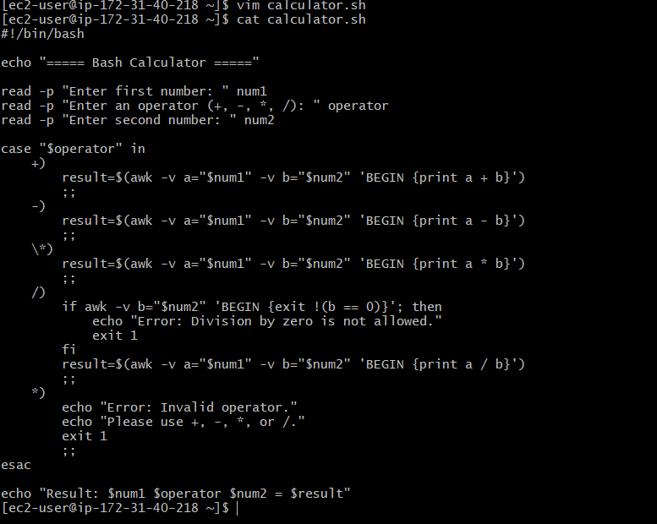

Step 3: Give Execute Permission
Run the following command:
chmod 755 calculator.sh
This makes the script executable.
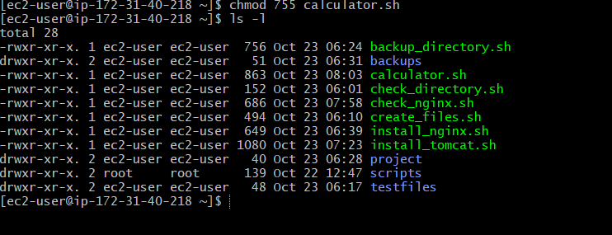

Step 4: Execute the Script
Run the calculator:
./calculator.sh
Enter the two numbers and the operator when prompted.
Example output:
===== Bash Calculator =====
Enter first number: 10
Enter an operator (+, -, *, /): +
Enter second number: 5
Result: 10 + 5 = 15

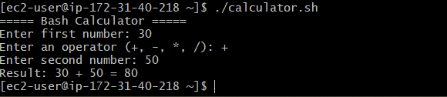

Step 5: Test Different Operations
Run the script again and test addition, subtraction, multiplication, and division.
Example results:
Addition: 10 + 5 = 15
Subtraction: 10 - 5 = 5
Multiplication: 10 * 5 = 50
Division: 10 / 5 = 2
The script uses awk to perform arithmetic, so it supports decimal numbers as well as integers.
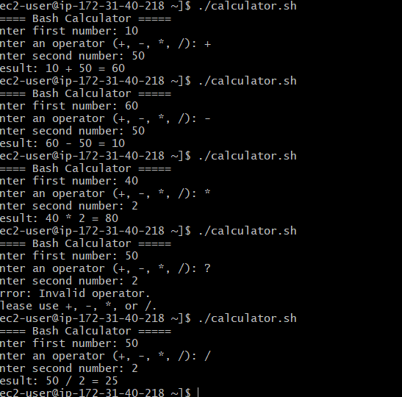

Validation Steps
No. | Test Case | Expected Result
1 | Enter 10, +, 5 | Result is 15
2 | Enter 10, -, 5 | Result is 5
3 | Enter 10, *, 5 | Result is 50
4 | Enter 10, /, 5 | Result is 2
5 | Enter 10, /, 0 | Division-by-zero error is displayed
6 | Enter an invalid operator such as % | Invalid-operator error is displayed
7 | Enter decimal numbers such as 2.5 and 1.5 with + | Result is 4

Explanation
read -p displays a prompt and accepts user input.
case checks which arithmetic operator the user selected.
awk calculates the result and supports decimal arithmetic.
if checks whether the divisor is zero before division.
* is escaped as \* in the case pattern so it is treated as a literal multiplication operator.
echo displays the calculation result.
exit 1 ends the script when an invalid operator or division-by-zero error occurs.

Real-Time Use Case
A Bash calculator can be used for quick calculations in Linux administration and DevOps scripts, such as calculating storage differences, resource usage, deployment counts, or simple numerical values during automated tasks.

Common Errors and Troubleshooting
Error | Possible Cause | Solution
Permission denied | Script is not executable | Run chmod +x calculator.sh
awk: command not found | awk is not installed | Install the appropriate awk package for your Linux distribution
Invalid operator message | Unsupported operator entered | Use +, -, *, or /
Division-by-zero error | Second number is zero during division | Enter a nonzero divisor
Unexpected result | Input is not a valid number | Enter numeric values such as 10, -3, or 2.5

Conclusion
A Bash calculator script was created to perform addition, subtraction, multiplication, and division. The script accepts user input, processes the selected operation, supports decimal arithmetic, and handles invalid operators and division by zero. This practical demonstrates the use of variables, input handling, conditional logic, and arithmetic operations in Bash scripting.
Task 8: Create a bash script to check if a directory exists, if not then create a directory

Outcome
A Bash script is created to check whether a specified directory exists. If the directory does not exist, the script creates it automatically.

Objective
To automate directory management in Linux using Bash scripting and conditional statements.

Prerequisites
- An EC2 instance running Linux, such as Amazon Linux 2023.
- SSH access to the EC2 instance, if working remotely.
- Bash shell installed.
- Basic knowledge of Linux commands and Bash scripting.

Step-by-Step Implementation

Step 1: Create the Bash Script
Create a file named check_directory.sh.
vim check_directory.sh

Step 2: Write the Script
Add the following code:
#!/bin/bash

# Check whether a directory path was provided
if [ -z "$1" ]; then
echo "Usage: $0 <directory_path>"
exit 1
fi

dir="$1"

# Check if the directory exists
if [ -d "$dir" ]; then
echo "Directory already exists: $dir"
else
echo "Directory does not exist: $dir"
echo "Creating directory..."

if mkdir -p "$dir"; then
echo "Directory created successfully: $dir"
else
echo "Error: Failed to create directory: $dir"
exit 2
fi
fi
Save the file and exit the editor.
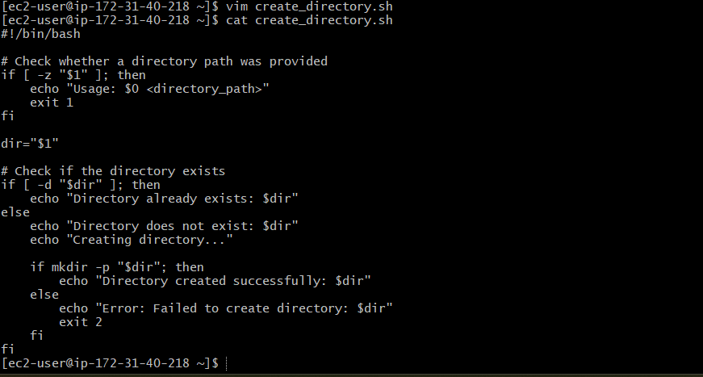

Step 3: Give Execute Permission
Run the following command:
chmod 755 check_directory.sh

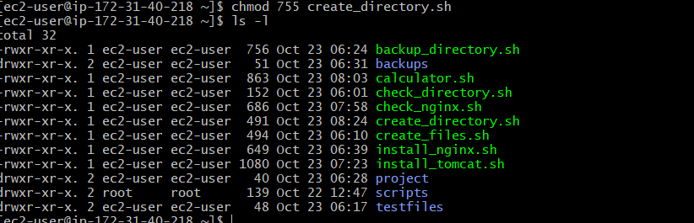

Step 4: Execute the Script
Pass the directory path as a command-line argument.
./check_directory1.sh /home/ec2-user/mydirectory
If the directory does not exist, the script creates it. If it already exists, the script displays a message and does not create it again.
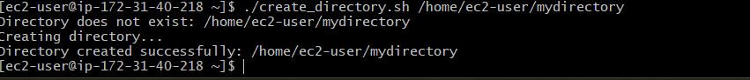

Step 5: Verify the Directory
Use the following command to check whether the directory exists:
ls -ld /home/ec2-user/mydirectory
If the directory was created successfully, its details will be displayed.

Validation Steps
No. | Test Case | Expected Result
1 | Run the script with a new directory path | The directory is created successfully
2 | Run the script with an existing directory path | The script reports that the directory already exists
3 | Run the script without an argument | Usage instructions are displayed
4 | Run the script with a path that cannot be created due to permissions | An error message is displayed
5 | Run ls -ld on the target directory | Directory details are displayed if it exists

Explanation
#!/bin/bash specifies the Bash interpreter.
"$1" represents the first command-line argument supplied to the script.
-z "$1" checks whether the argument is empty.
-d "$dir" checks whether the specified path is an existing directory.
mkdir -p "$dir" creates the directory, including any missing parent directories.
if and else control the script's decision-making.
exit 1 and exit 2 indicate input or directory-creation errors.

Real-Time Use Case
In DevOps environments, scripts often need directories for application logs, backups, deployment files, and temporary data. This script ensures that a required directory exists before another automation task runs.

Common Errors and Troubleshooting
Error | Possible Cause | Solution
Permission denied | Insufficient permission to create the directory | Choose a directory you can write to or use authorized sudo access
Usage message appears | No directory path was provided | Supply a path when executing the script
Directory already exists | The target directory was previously created | No action is required
mkdir fails | Invalid path or filesystem issue | Check the path and filesystem permissions
Script does not execute | Execute permission is missing | Run chmod +x check_directory.sh

Conclusion
A Bash script was created to check whether a directory exists and create it when necessary. The script accepts a directory path as an argument, handles existing directories, and reports errors if creation fails. This practical demonstrates conditional statements, command-line arguments, and directory management in Linux.
Task 9: Create a bash script to delete the last 3 lines of a file.

Outcome
A Bash script is created to remove the last three lines from a specified file and save the modified content.

Objective
To automate file editing in Linux using Bash scripting and the sed command to delete the last three lines of a file.

Prerequisites
- An EC2 instance running Linux, such as Amazon Linux 2023.
- SSH access to the EC2 instance, if working remotely.
- Bash shell installed.
- A text file containing at least three lines.
- Basic knowledge of Linux commands and Bash scripting.

Step-by-Step Implementation

Step 1: Create a Sample File
Create a file named sample.txt.
vim sample.txt
Add some sample content:
Line 1: Welcome to Linux
Line 2: Learning Bash scripting
Line 3: File handling practice
Line 4: DevOps practical
Line 5: AWS EC2 server
Line 6: End of file
Save and exit the editor.
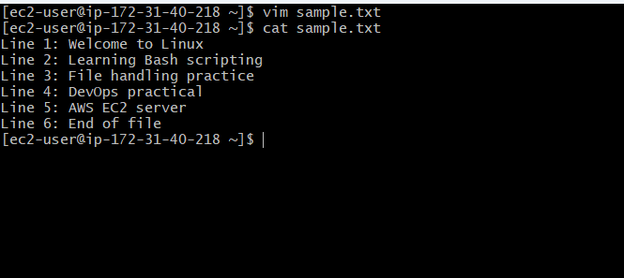

Step 2: Create the Bash Script
Create a script named delete_last3.sh.
vim delete_last3.sh
Add the following code:
#!/bin/bash

# Check whether a filename was provided
if [ "$#" -ne 1 ]; then
echo "Usage: $0 <filename>"
exit 1
fi

file="$1"

# Check whether the file exists
if [ ! -f "$file" ]; then
echo "Error: File does not exist: $file"
exit 2
fi

# Check whether the file is writable
if [ ! -w "$file" ]; then
echo "Error: File is not writable: $file"
exit 3
fi

# Keep a backup before modifying the original file
cp -p -- "$file" "$file.bak" || {
echo "Error: Could not create backup."
exit 4
}

# Delete the last three lines
if sed -i '$d' "$file" &&
sed -i '$d' "$file" &&
sed -i '$d' "$file"; then
echo "Last 3 lines deleted successfully."
echo "Updated file: $file"
echo "Backup file: $file.bak"
else
echo "Error: Failed to update the file."
echo "A backup is available at: $file.bak"
exit 5
fi
Save the file and exit the editor.
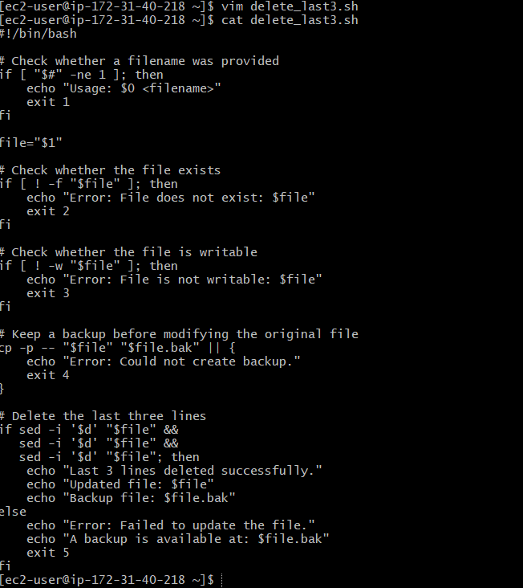

Step 3: Give Execute Permission
chmod 755 delete_last3.sh

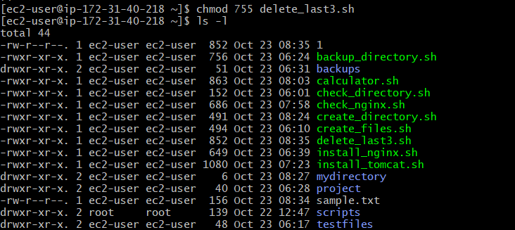

Step 4: View the Original File
cat sample.txt
The file should display all six lines.
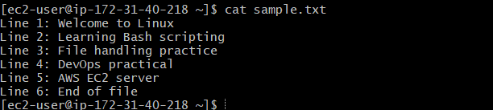

Step 5: Execute the Script
./delete_last3.sh sample.txt
Expected output:
Last 3 lines deleted successfully.
Updated file: sample.txt
Backup file: sample.txt.bak

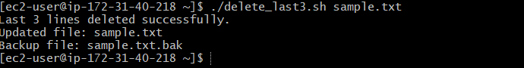

Step 6: Verify the Updated File
cat sample.txt
Expected output:
Line 1: Welcome to Linux
Line 2: Learning Bash scripting
Line 3: File handling practice
The last three lines have been removed. The original file's content is preserved in sample.txt.bak.
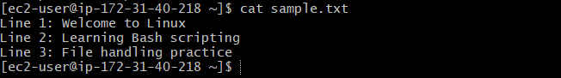

Validation Steps
No. | Test Case | Expected Result
1 | Run the script on a file with six lines | The final three lines are deleted
2 | Run the script on a file with fewer than three lines | All existing lines are deleted
3 | Run the script without a filename | Usage instructions are displayed
4 | Specify a nonexistent file | An error message is displayed
5 | Check sample.txt.bak | The original file content is preserved

Explanation
"$#" checks the number of arguments supplied to the script.
-f checks whether the specified path is a regular file.
-w checks whether the file is writable by the current user.
cp -p creates a backup and preserves basic file attributes.
sed -i '$d' deletes the last line of the file in place.
Running the command three times removes the last three lines.
cat displays the file content for verification.
Important: This script modifies the original file. It creates a .bak backup first, but you should still test it on a sample file before using it on important data.

Real-Time Use Case
In DevOps environments, automated scripts may be used to remove trailing entries from configuration files, test files, or generated text files. Always verify the file format and create a backup before modifying production configuration files.

Common Errors and Troubleshooting
Error | Possible Cause | Solution
Permission denied | The script is not executable or the file cannot be modified | Run chmod +x delete_last3.sh and check file permissions
File does not exist | Incorrect filename or path | Verify the path using ls -l
No lines remain | The file contained three or fewer lines | Check the file before running the script
Backup creation fails | Insufficient directory permissions or insufficient disk space | Check permissions and available disk space
Unexpected content is deleted | The wrong file was supplied | Restore the content from the .bak backup if needed

Conclusion
A Bash script was created to delete the last three lines of a specified file using the sed command. The script validates the filename, checks file permissions, creates a backup, and modifies the file. This practical demonstrates Bash argument handling, file validation, backup creation, and text-file manipulation.
Task 10: Bash script to monitor cpu and if it is more than 80% then send email notification.

Outcome
A Bash script is created to monitor CPU utilization on an EC2 Linux server. If CPU usage exceeds 80%, the script sends an email alert to a specified recipient.

Objective
To automate CPU monitoring and email notifications using Bash scripting, helping administrators identify high CPU utilization before it affects server performance.

Prerequisites
- An AWS EC2 instance running Amazon Linux 2023 or another Linux distribution.
- SSH access to the EC2 instance.
- Bash shell and the top command.
- An email utility such as mailx.
- A configured SMTP server or mail transfer agent to deliver emails.
- A valid recipient email address.

Step-by-Step Implementation

Step 1: Connect to the EC2 Instance
Connect to your EC2 instance using Git Bash.
ssh -i "your-key.pem" ec2-user@YOUR_EC2_PUBLIC_IP
Replace the key filename and public IP address with your EC2 details.

Step 2: Install the Required Packages
For Amazon Linux 2023, install mailx and sysstat:
sudo dnf install -y mailx sysstat
The mailx utility sends email through a configured mail delivery system. The sysstat package provides CPU monitoring tools such as mpstat. Installing these packages alone does not configure email delivery. <Cite refs={["turn808055search8","turn808055search12"]}/>
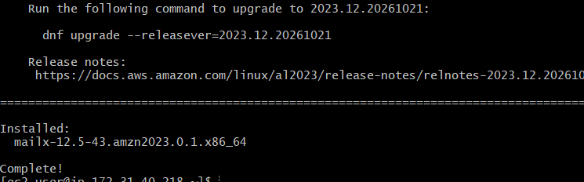

Step 3: Configure Email Delivery
Configure mailx to use your organization's SMTP server or another authorized email service. You will need the SMTP server details, sender address, authentication settings if required, and recipient address.
Test email delivery before creating the monitoring script:
echo "This is a test email from the EC2 server." \
| mailx -s "CPU Monitoring Test" your-email@example.com
Replace your-email@example.com with your email address.
Confirm that the message arrives. If it does not, troubleshoot the mail delivery configuration before proceeding.
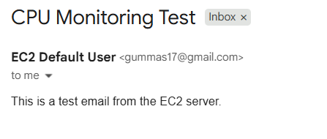

Step 4: Create the Bash Script
Create a file named cpu_monitor.sh.
vim cpu_monitor.sh
Add the following code:
#!/bin/bash

THRESHOLD=80
RECIPIENT="your-email@example.com"

# Calculate CPU usage percentage
CPU_IDLE=$(LC_ALL=C mpstat 1 1 | awk '/Average:/ && $2 == "all" {print $NF}')

if ! [[ "$CPU_IDLE" =~ ^[0-9]+([.][0-9]+)?$ ]]; then
echo "Error: Could not determine CPU usage."
exit 1
fi

CPU_USAGE=$(awk -v idle="$CPU_IDLE" \
'BEGIN {printf "%.2f", 100 - idle}')

echo "Current CPU usage: ${CPU_USAGE}%"

# Compare CPU usage with the threshold
if awk -v usage="$CPU_USAGE" -v limit="$THRESHOLD" \
'BEGIN {exit !(usage > limit)}'; then

SUBJECT="ALERT: High CPU Usage on $(hostname)"
MESSAGE="CPU usage on $(hostname) is ${CPU_USAGE}%.
Threshold: ${THRESHOLD}%
Time: $(date)"

if printf '%s\n' "$MESSAGE" | mailx -s "$SUBJECT" "$RECIPIENT"; then
echo "Email alert submitted to the mail system."
else
echo "Error: Failed to submit the email alert."
exit 2
fi
else
echo "CPU usage is within the threshold. No email required."
fi
Replace your-email@example.com with your recipient email address.
Save the file and exit the editor.
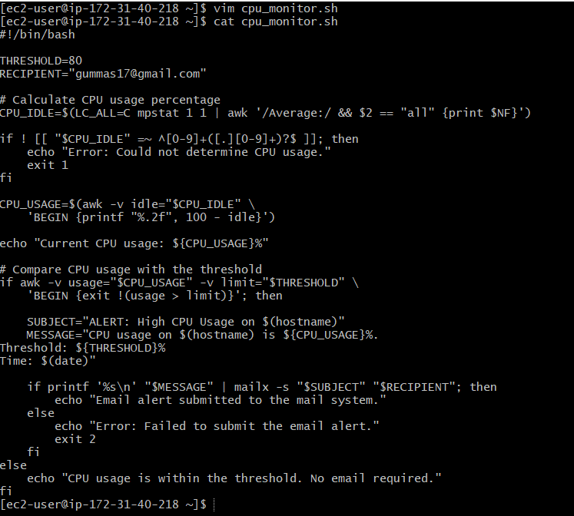

Step 5: Give Execute Permission
chmod 755 cpu_monitor.sh

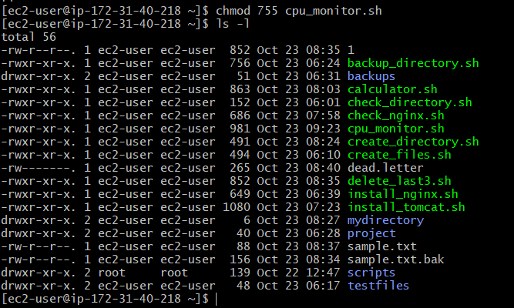

Step 6: Run the Script
Execute the script:
./cpu_monitor.sh
Example output when CPU usage is below the threshold:
Current CPU usage: 25.40%
CPU usage is within the threshold. No email required.
Example output when CPU usage exceeds the threshold:
Current CPU usage: 85.20%
Email alert submitted to the mail system.
The email notification is delivered only if the mail system is configured and the message is successfully submitted. Actual delivery should be verified in the recipient's mailbox.
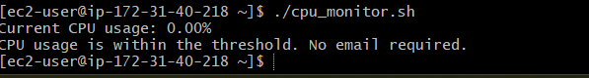

Step 7: Schedule Automatic Monitoring
To run the script every five minutes, edit the user's cron schedule:
crontab -e
Add the following line, replacing the path with the actual location of your script:
*/5 * * * * /home/ec2-user/cpu_monitor.sh >> /home/ec2-user/cpu_monitor.log 2>&1
Save and exit. The script will check CPU utilization every five minutes and submit an email alert whenever the measured CPU usage is above 80%.
Note: This basic version can send an alert at every check while CPU usage remains above 80%. For production use, add alert suppression or a cooldown period to prevent repeated emails.

Validation Steps
No. | Test | Expected Result
1 | Run mpstat 1 1 | CPU statistics are displayed
2 | Run ./cpu_monitor.sh under normal load | CPU usage is displayed; no alert is sent if usage is 80% or lower
3 | Run the script when CPU usage exceeds 80% | An email alert is submitted to the mail system
4 | Check the recipient inbox | The alert email is received if mail delivery is configured correctly
5 | Run crontab -l | The scheduled monitoring entry is displayed
6 | Inspect cpu_monitor.log | The script's output and errors are recorded

Explanation
THRESHOLD=80 sets the CPU usage threshold to 80%.
mpstat 1 1 samples CPU statistics over a one-second interval.
awk reads the idle CPU percentage and calculates usage as 100 - idle.
The numeric comparison checks whether CPU usage is strictly greater than 80%.
mailx -s specifies the subject of the notification email.
date records when the alert was generated.
crontab schedules the script to run automatically.
The measured CPU usage is a short sample, not a long-term average. For production monitoring, consider sampling over a longer interval and using a cooldown or sustained-threshold rule.

Real-Time Use Case
In DevOps environments, high CPU utilization can slow down applications and services hosted on EC2 instances. Automated CPU monitoring helps administrators identify resource pressure and respond before it causes significant performance issues.

Common Errors and Troubleshooting
Error | Possible Cause | Solution
mpstat: command not found | sysstat is not installed | Run sudo dnf install -y sysstat on Amazon Linux 2023
CPU usage cannot be determined | Unexpected command output or locale differences | Run mpstat 1 1 manually and inspect its output
mailx: command not found | Email utility is missing | Install mailx using the package manager
Email is not received | SMTP or mail transfer agent is not configured | Configure email delivery and send a test message
Authentication failure | Incorrect SMTP credentials or settings | Verify SMTP authentication and sender configuration
Script does not run through cron | Incorrect script path or environment | Use absolute paths and inspect cpu_monitor.log
Too many alert emails | CPU stays above the threshold across repeated checks | Implement a cooldown period or send alerts only when usage crosses the threshold

Conclusion
A Bash script was created to monitor CPU utilization on an EC2 Linux server and send an email notification when CPU usage exceeds 80%. The script calculates CPU usage, compares it with the configured threshold, and submits an email alert when required. Configured email delivery and scheduled execution allow this script to serve as a basic automated monitoring solution.
Task 11: Bash script to monitor disk space and if it is more than 80% then send email notification

Outcome
A Bash script is created to monitor disk space utilization on an EC2 Linux server and attempt to send an email alert when disk usage exceeds 80%.

Objective
To automate disk space monitoring and notify the administrator when a filesystem reaches a high utilization level.

Prerequisites
- AWS EC2 instance running Amazon Linux 2023.
- SSH access to the instance.
- Bash shell and the df command.
- mailx installed.
- A configured SMTP server or email relay.
- A valid recipient email address.

Step-by-Step Implementation

Step 1: Check Disk Usage
df -h
This command displays filesystem size, used space, available space, and usage percentage.

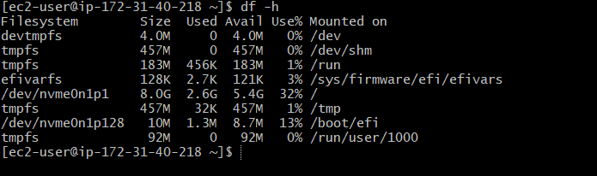

Step 2: Create the Bash Script
vim disk_monitor.sh
Add the following code:
#!/bin/bash

THRESHOLD=80
RECIPIENT="your-email@example.com"

echo "Checking disk space utilization..."

df -P -x tmpfs -x devtmpfs | awk 'NR > 1 {print $5, $6}' |
while read -r usage mountpoint; do

usage=${usage%\%}

if [ "$usage" -gt "$THRESHOLD" ]; then
SUBJECT="ALERT: High Disk Usage on $(hostname)"

MESSAGE="High disk usage detected.
Server: $(hostname)
Mount Point: $mountpoint
Disk Usage: ${usage}%
Threshold: ${THRESHOLD}%
Time: $(date)"

echo "$MESSAGE"

if printf '%s\n' "$MESSAGE" |
mailx -s "$SUBJECT" "$RECIPIENT"; then
echo "Email alert submitted for $mountpoint."
else
echo "Error: Email submission failed for $mountpoint."
fi
else
echo "Disk usage on $mountpoint is ${usage}%. Normal."
fi
done
Replace your-email@example.com with the recipient's email address. Save and exit the editor.
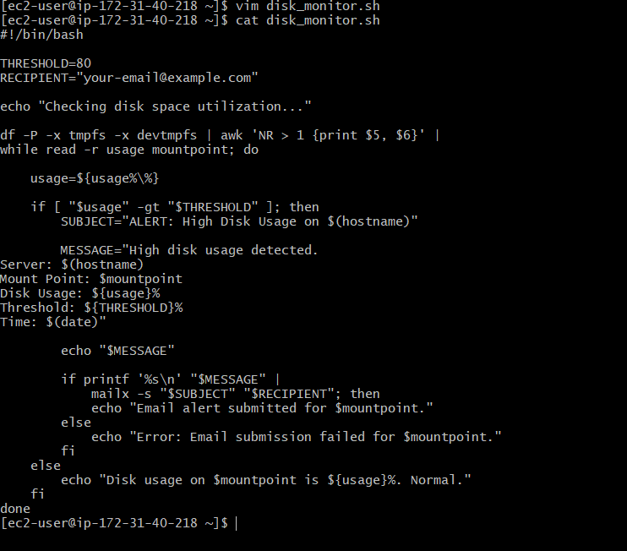

Step 3: Make the Script Executable
chmod 755 disk_monitor.sh

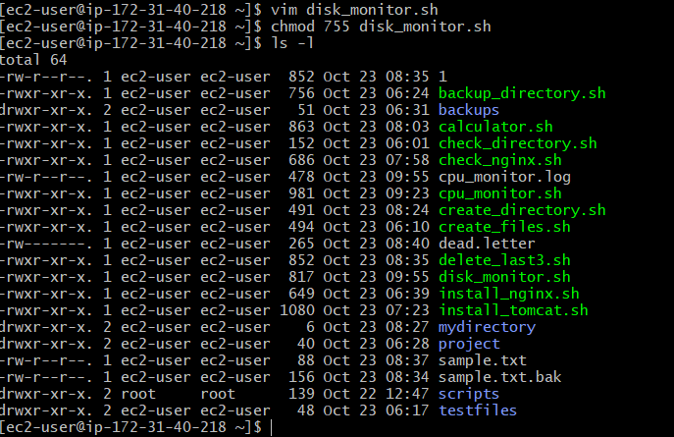

Step 4: Run the Script
./disk_monitor.sh
If disk usage is greater than 80%, the script attempts to submit an email alert. Otherwise, it reports that the filesystem is within the threshold.
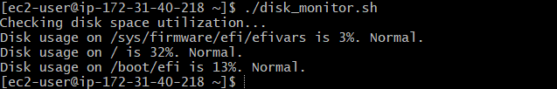

Step 5: Configure Email Delivery
The EC2 server must have a working mail transfer agent and SMTP relay. Installing mailx alone is not sufficient.
To install Postfix on Amazon Linux 2023:
sudo dnf install -y postfix
sudo systemctl enable --now postfix
Important: Postfix must also be configured to relay email through an authorized SMTP provider, such as Amazon SES. Verify email delivery with a test message before relying on the monitoring script.
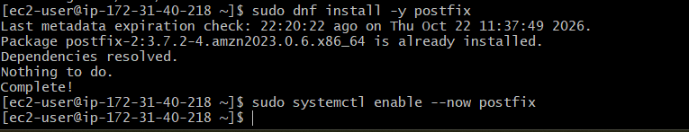

Step 6: Schedule Automatic Monitoring
Open the cron editor:
crontab -e
Add this entry:
*/5 * * * * /home/ec2-user/disk_monitor.sh >> /home/ec2-user/disk_monitor.log 2>&1
This schedules the script to run every five minutes. Adjust the script path if necessary.

Validation Steps
No. | Test | Expected Result
1 | Run df -h | Filesystem usage is displayed
2 | Run the script when usage is below 80% | Normal usage message appears
3 | Test a filesystem with usage above 80% | Alert message is generated
4 | Verify SMTP delivery | Email arrives if the relay is configured correctly
5 | Run crontab -l | Scheduled monitoring entry is displayed

Explanation
df -P retrieves filesystem utilization in a predictable format.
awk extracts the usage percentage and mount point.
${usage%\%} removes the percentage symbol.
-gt checks whether utilization is strictly greater than 80.
mailx -s submits the notification email.
crontab automates periodic monitoring.

Real-Time Use Case
DevOps administrators use disk monitoring to identify storage pressure on application servers, database systems, and cloud instances. Early alerts help prevent failures caused by full filesystems.

Common Errors and Troubleshooting
Error | Possible Cause | Solution
mailx: command not found | Email utility is missing | Install mailx
/usr/sbin/sendmail: No such file or directory | Mail transfer agent is missing | Install and configure a mail transfer agent
Email is not received | SMTP relay or authentication is incorrect | Test the relay and inspect mail logs
Permission denied | Script lacks execute permission | Run chmod +x disk_monitor.sh
Cron job does not run | Incorrect path or permissions | Use an absolute path and check the log file

Conclusion
A Bash script was created to monitor disk space utilization and attempt to send an email notification when usage exceeds 80%. Scheduling the script with cron enables regular monitoring. A working SMTP relay is required for email alerts to reach the recipient.
Task 12:Bash script to monitor memory and if it is more than 80% then send email notification

Outcome
A Bash script is created to monitor memory utilization on an EC2 Linux server and attempt to send an email notification when memory usage exceeds 80%.

Objective
To automate memory monitoring and notify the system administrator when RAM utilization becomes high, helping prevent performance issues on the EC2 instance.

Prerequisites
- AWS EC2 instance running Amazon Linux 2023 or another Linux distribution.
- SSH access to the instance.
- Bash shell and the free command.
- mailx installed.
- A configured SMTP server or email relay.
- A valid recipient email address.

Step-by-Step Implementation

Step 1: Check Current Memory Usage
Run the following command:
free -h
This displays total, used, free, shared, cache, and available memory.
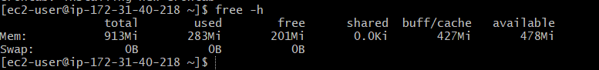

Step 2: Create the Bash Script
Create a file named memory_monitor.sh.
vim memory_monitor.sh
Add the following code:
#!/bin/bash

THRESHOLD=80
RECIPIENT="your-email@example.com"

echo "Checking memory utilization..."

# Calculate memory usage percentage
MEMORY_USAGE=$(free | awk '/Mem:/ {
if ($2 > 0)
printf "%.0f", (($2 - $7) / $2) * 100
}')

if ! [[ "$MEMORY_USAGE" =~ ^[0-9]+$ ]]; then
echo "Error: Could not determine memory usage."
exit 1
fi

echo "Current memory usage: ${MEMORY_USAGE}%"

# Check whether memory usage exceeds the threshold
if [ "$MEMORY_USAGE" -gt "$THRESHOLD" ]; then

SUBJECT="ALERT: High Memory Usage on $(hostname)"

MESSAGE="High memory usage detected.
Server: $(hostname)
Memory Usage: ${MEMORY_USAGE}%
Threshold: ${THRESHOLD}%
Time: $(date)

Memory details:
$(free -h)"

echo "$MESSAGE"

if printf '%s\n' "$MESSAGE" |
mailx -s "$SUBJECT" "$RECIPIENT"; then
echo "Email alert submitted to the mail system."
else
echo "Error: Failed to submit email alert."
exit 2
fi
else
echo "Memory usage is within the threshold. No email required."
fi
Replace your-email@example.com with the recipient's email address. Save and exit the editor.
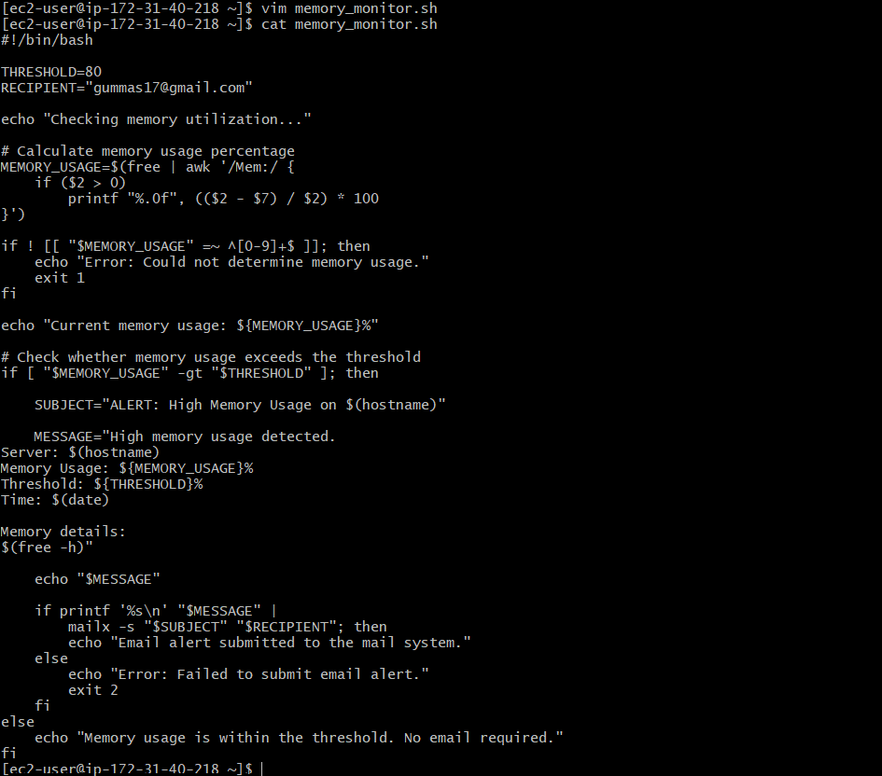

Step 3: Make the Script Executable
chmod 755 memory_monitor.sh

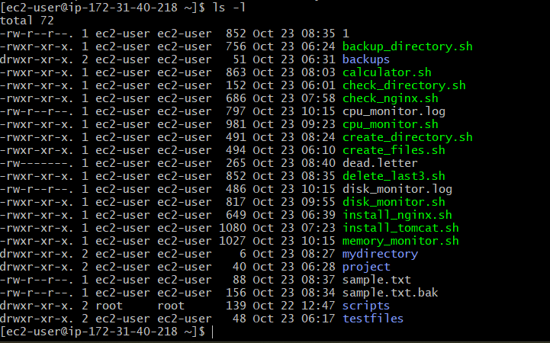

Step 4: Execute the Script
./memory_monitor.sh
Example output when memory usage is below 80%:
Checking memory utilization...
Current memory usage: 45%
Memory usage is within the threshold. No email required.
Example output when memory usage exceeds 80%:
Checking memory utilization...
Current memory usage: 85%
High memory usage detected.
Server: ip-172-31-37-177
Memory Usage: 85%
Threshold: 80%
Email alert submitted to the mail system.
The actual percentage and hostname will depend on your EC2 instance.
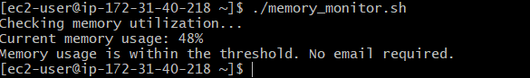

Step 5: Configure Email Delivery
The script requires a working mail transfer agent and SMTP relay. Installing mailx alone does not guarantee that email can be delivered.
On Amazon Linux 2023, Postfix can be installed using:
sudo dnf install -y postfix
sudo systemctl enable --now postfix
External email delivery still requires configuring Postfix with an authorized SMTP relay, such as Amazon SES. Test email delivery before relying on the alert.

Step 6: Schedule Automatic Monitoring
Open the cron editor:
crontab -e
Add the following line to run the script every five minutes:
*/5 * * * * /home/ec2-user/memory_monitor.sh >> /home/ec2-user/memory_monitor.log 2>&1
Adjust the path if you saved the script elsewhere.
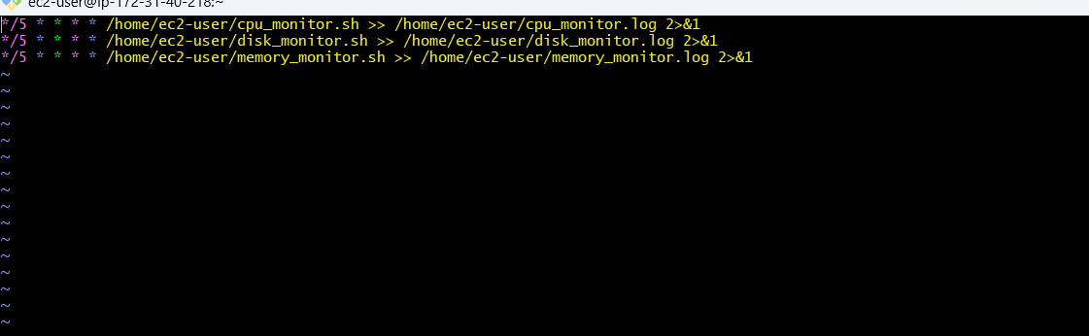

Validation Steps
No. | Test | Expected Result
1 | Run free -h | Memory statistics are displayed
2 | Execute the script when usage is below 80% | Normal usage message appears
3 | Execute the script when usage exceeds 80% | An alert message is generated
4 | Verify SMTP delivery | Email arrives if mail delivery is configured
5 | Run crontab -l | Scheduled monitoring entry is displayed
6 | Inspect memory_monitor.log | Script output and errors are recorded

Explanation
free retrieves memory statistics.
awk calculates memory usage using total memory and available memory.
THRESHOLD=80 defines the alert threshold.
-gt checks whether usage is strictly greater than 80%.
mailx -s submits the email with the specified subject.
hostname identifies the server.
date records the alert time.
crontab schedules recurring monitoring.
Note: The script calculates memory usage as total memory minus available memory, which better reflects memory pressure on Linux than simply counting memory marked as used. The percentage is rounded to a whole number.

Real-Time Use Case
In DevOps environments, high memory usage can slow applications, cause out-of-memory errors, or trigger process termination. Automated memory monitoring helps administrators detect potential resource issues and investigate before application performance is affected.

Common Errors and Troubleshooting
Error | Possible Cause | Solution
free: command not found | Required system utility is unavailable | Check the operating system and command path
mailx: command not found | Email utility is missing | Install mailx
/usr/sbin/sendmail: No such file or directory | Mail transfer agent is missing | Install and configure a mail transfer agent and SMTP relay
Email is not received | SMTP relay or authentication is incorrect | Test the relay and inspect mail logs
Script cannot execute | Missing execute permission | Run chmod +x memory_monitor.sh
Cron job does not run | Incorrect path or permissions | Use an absolute path and inspect the log file

Conclusion
A Bash script was created to monitor memory utilization on an EC2 Linux server and attempt to send an email notification when usage exceeds 80%. The script uses free to calculate memory utilization and mailx to submit an alert. A working SMTP relay and scheduled execution are required for reliable automated notifications.

